Weekly Agenda 8/29 – 9/2
Brit Lit and Comp – McBride
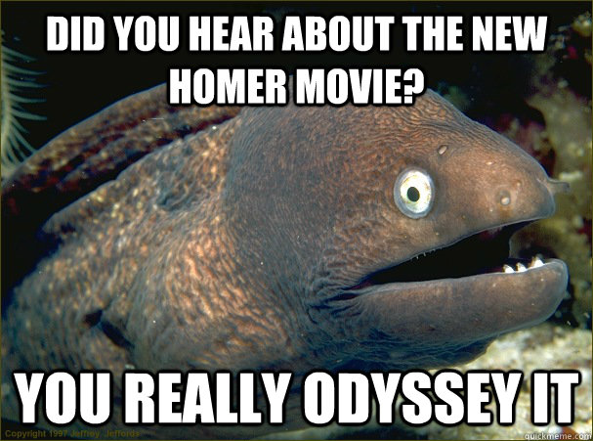
Mon 29 – Laptop cart
- ACT WOTD/SAT QOTD
- PSW Training (obligatory)
- Reflect on Junior Year Writing…Writing Folders/Goals
- Prep for On-Demand Argument Writing
  - Time, structure, rubric, close reading
- HW – Prepare TE you will use for essay tomorrow!
Tues. 30 – Laptop Cart
- Hero/Journey On-demand Comp
- HW – TBA
Wed. 31
- ACT WOTD/SAT QOTD
- Writer’s Workshop - Evaluating the claim (thesis) and the evidence
- HW - Revise essay!
Thurs. 1 – Senior College Planning Parent meeting at 7 pm!
- QW – What is an Odyssey…where have you heard the word before?
- Collect Revised Hero/Journey essay
- Crash Course…Start reading Book IX together
- HW – Finish reading Book IX
Fri. 2
- QW – Book IX Reading Check
- Silent reading, Odyssey Book XII
- HW – Finish reading Book XII, add to IC!
CCSS.ELA-LITERACY.W.11-12.1
Write arguments to support claims in an analysis of substantive topics or texts, using valid reasoning and relevant and sufficient evidence.
CCSS.ELA-LITERACY.RL.11-12.1
Cite strong and thorough textual evidence to support analysis of what the text says explicitly as well as inferences drawn from the text, including determining where the text leaves matters uncertain.

Weekly Agenda 8/29 – 9/2
Brit Lit and Comp – McBride
Mon 29 – Laptop cart
- ACT WOTD/SAT QOTD
- PSW Training (obligatory)
- Reflect on Junior Year Writing…Writing Folders/Goals
- Prep for On-Demand Argument Writing
  - Time, structure, rubric, close reading
- HW – Prepare TE you will use for essay tomorrow!
Tues. 30 – Laptop Cart
- Hero/Journey On-demand Comp
- HW – TBA
Wed. 31
- ACT WOTD/SAT QOTD
- Writer’s Workshop - Evaluating the claim (thesis) and the evidence
- HW - Revise essay!
Thurs. 1 – Senior College Planning Parent meeting at 7 pm!
- QW – What is an Odyssey…where have you heard the word before?
- Collect Revised Hero/Journey essay
- Crash Course…Start reading Book IX together
- HW – Finish reading Book IX
Fri. 2
- QW – Book IX Reading Check
- Silent reading, Odyssey Book XII
- HW – Finish reading Book XII, add to IC!
CCSS.ELA-LITERACY.W.11-12.1
Write arguments to support claims in an analysis of substantive topics or texts, using valid reasoning and relevant and sufficient evidence.
CCSS.ELA-LITERACY.RL.11-12.1
Cite strong and thorough textual evidence to support analysis of what the text says explicitly as well as inferences drawn from the text, including determining where the text leaves matters uncertain.

